Azure DevOps

* Login to <https://dev.azure.com/> and Setup your Organization.

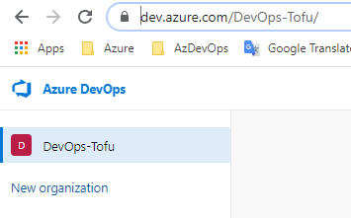

* I have Created DevOps-Tofu , once its done – create a project (Can specify the project as per your framework ). Public or Private- its your choice.

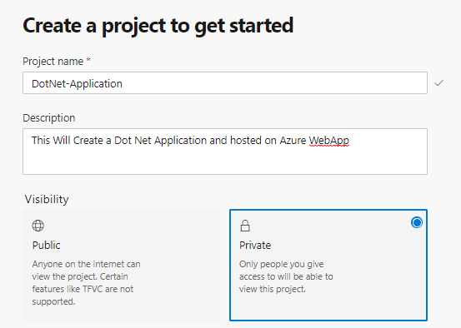

DevOps Page – Over view. 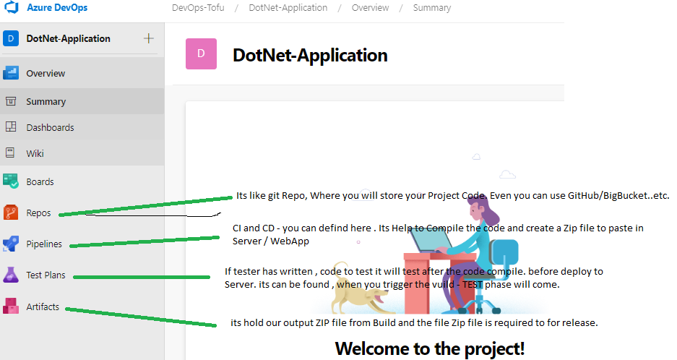

* **Repo** - Clone the Repo to Local OR Create a Local Repo and Set upstream to your AzRepo.

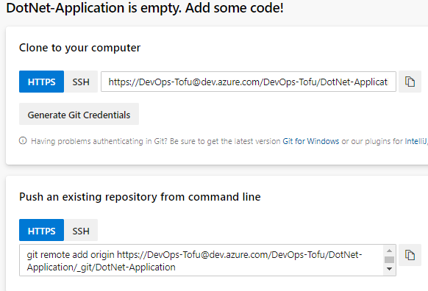

Check the "D:\Study Material\DevOps\Git\Git Commands.txt" file for git command.

* After adding code to local Repo 🡪 push to Remote Repo. Create Dev, Test 🡪 Branch for different environment.

README File Added to locally then push it to Origin.

Compare the logs of both repo – both are having same Commit ID.

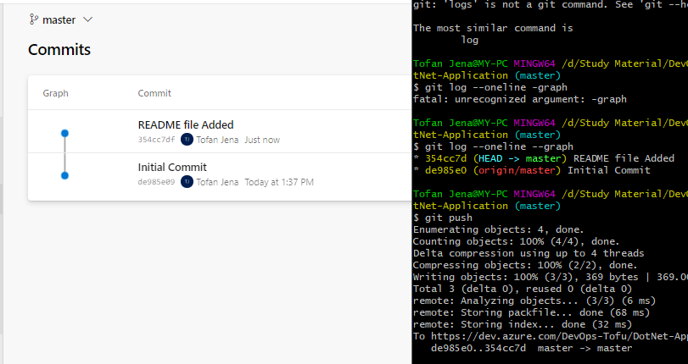

* Test and DEV Branches has been created.

Note- Test Branch created based on Master Branch and DEV Branch Created based on Test Branch. Why So.?? Once developer done with code – Branch need to merge/pull . As Same level branch can’t merge/pull themselves, hence we have created Dev Branch based on Test.

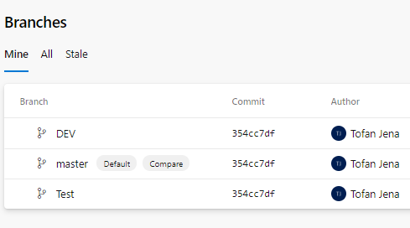

* **Continuous integration Pipeline: -**
* Got to Pipeline🡪Create Pipeline🡪 Click on **Classic Editor** 🡪 Select your Source Code 🡪Select Repository 🡪 Select Branch for Build; first we need to build the code at Dev System, hence I have selected **DEV** Branch.

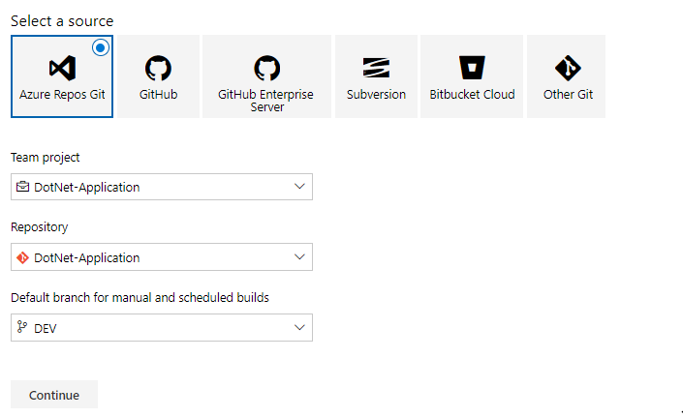

* Select the Build Agent – As we have DotNet Web application- I am selecting ASP.NET. and **Apply.**

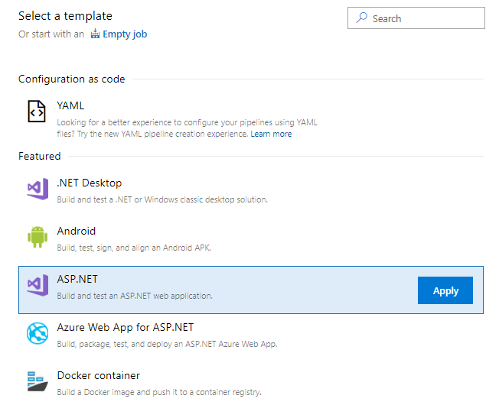

* Agent Pool, is basically a server where our code will build. And the has to have the required application, Nuget file, Dependency file etc , as we learnt in JENKINS. We will Build our own Agent to build the code – as its can be security breach.

As we know, *.sln is the solution file for .net application, this file required to download the dependency file written in Package.Config , same thing we done in Jenkins.

After the build, we use to get a ZIP if in our Workspace folder in JENKINS, here its asking us to set the folder, we can change the name as per our requirement.

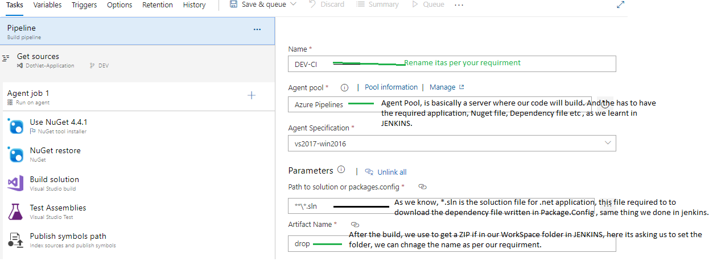

* **Agent Job-1**

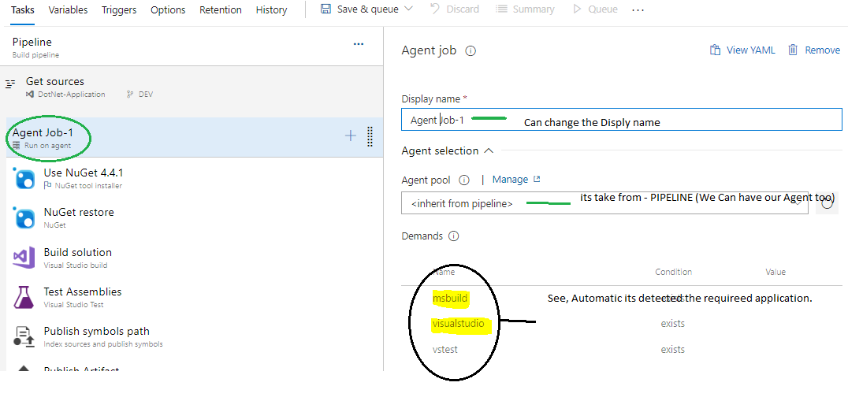

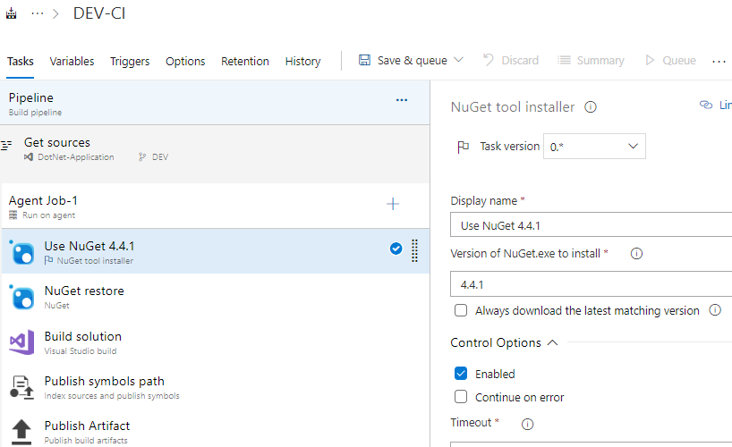

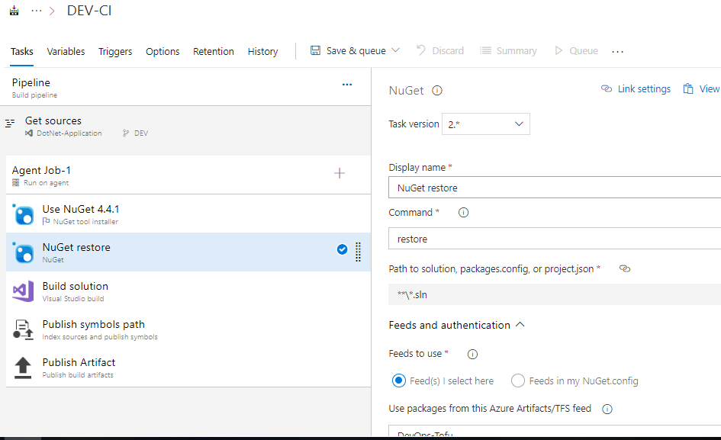

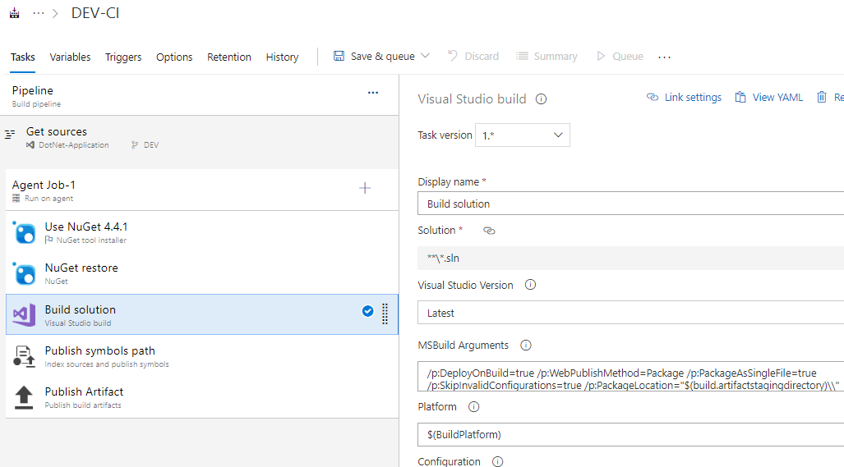

**#** No Much Changes required in Task Tab, Variable Tab – also its depend on Project ,

Trigger🡪 Enable continuous integration, Specify the Branch (DEV-as we are preparing CI for DEV). Option Tab and Retention Tab , is not required for Demo, its most come in live project.

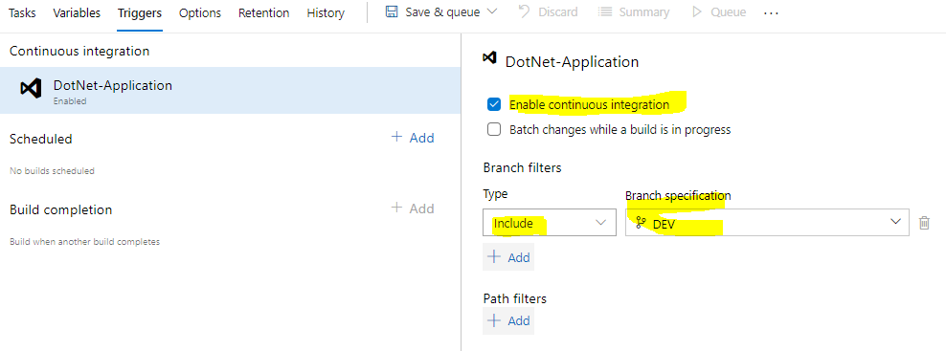

Now Save and Queue🡪 its start Build the code.

* **Continuous Release Pipeline: -**

Go to Pipeline🡪Release🡪New Pipeline🡪Select Azure App Service Deployment🡪Add the Artifact by click on **+Add**  (Ensure you select the Correct Build name).

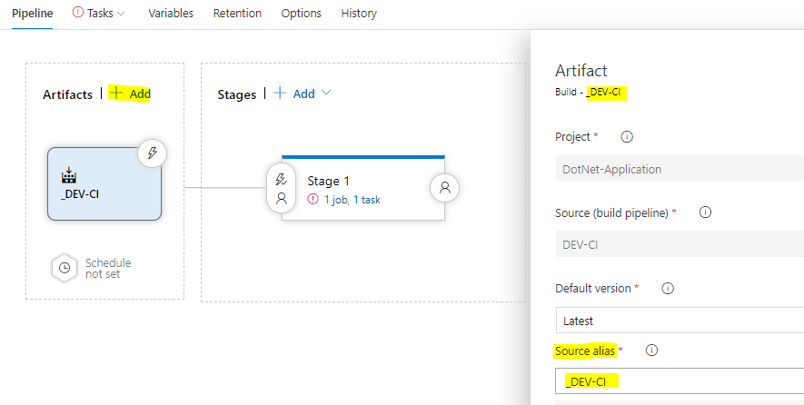

Continues Deploy -🡪 Click on the Highlited ICON , to Enable Continuous Deployment rigger

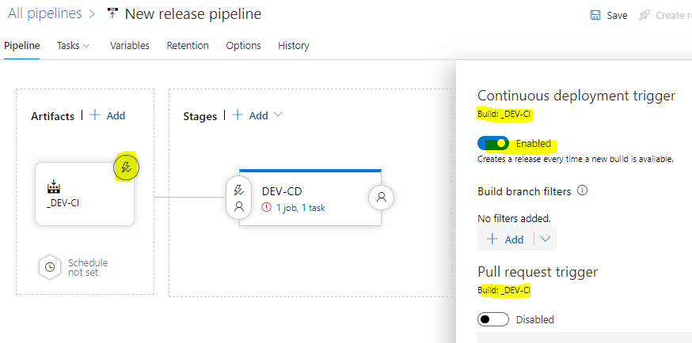

Now, Click on the **Stage1**  to **DEV-CI 🡪** click on 1jib, 1 task 🡪 in order to select the Subscription and WebApp , first need to create a service connection from **Project Setting🡪Service Connection.**

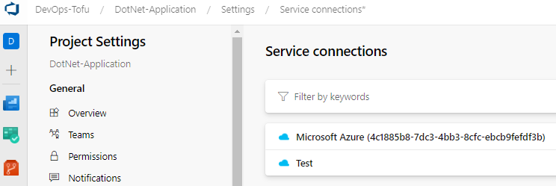

I have created a Test Connection and one Microsoft Azure – You can use any one.

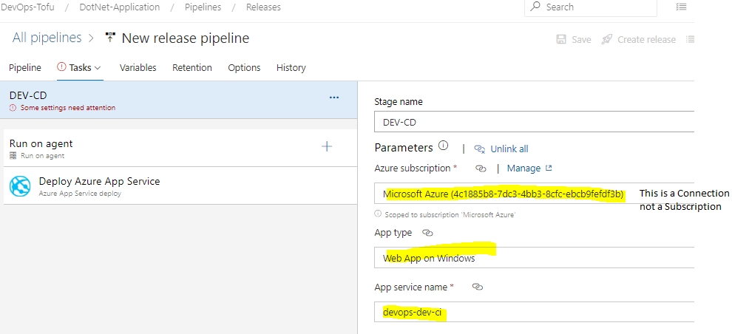

Click on Save 🡪 Change the mouse courser to **deploy azure app service** then only Save option will highlite. Click on Release 🡪